Caravan Accessories C.A.K. Tanks Ltd
Aqua House, 10 Princes Drive Industrial Estate,
Kenilworth, Nr. Coventry, Warwickshire CV8 2FD
Tel: 0844 414 2324 Fax: 0844 414 2425
Email: sales@caktanks.co.uk

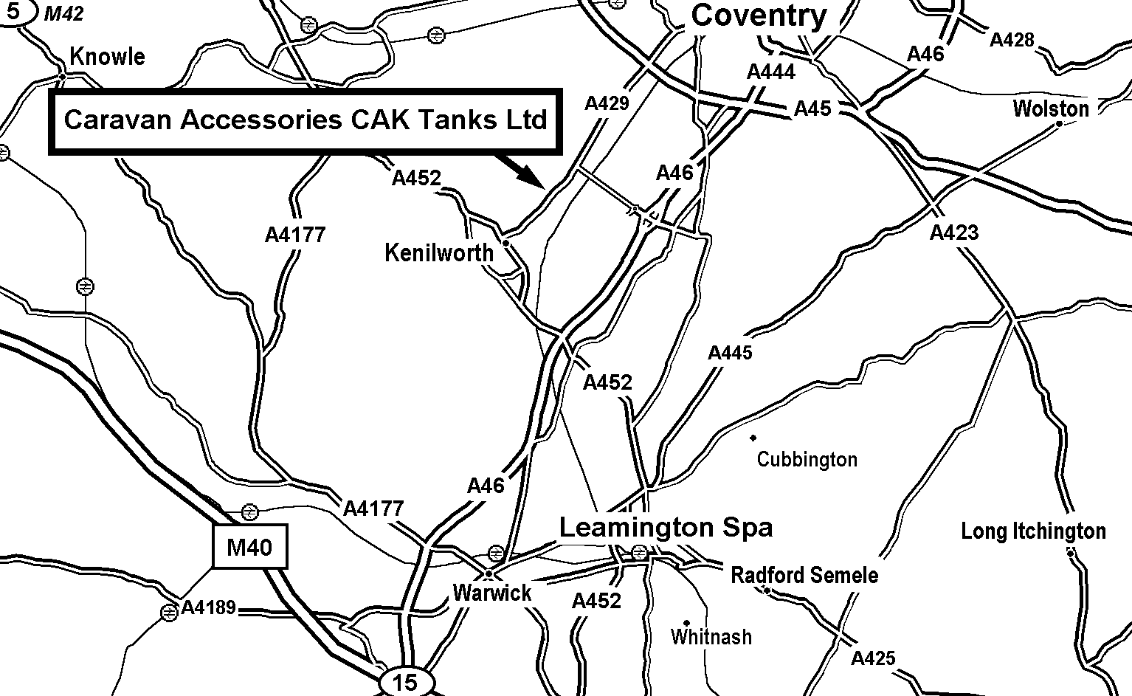

Exit the M40 (J-15) and head towards Coventry on the A46. Come off at the junction marked University of Warwick & Stoneleigh. Follow the signposts to the University until you come to the traffic lights. Turn Left (A429), after approximately 1½ miles take the turning on the right opposite the bus stop & phone box. Look for C.A.K. on our building.

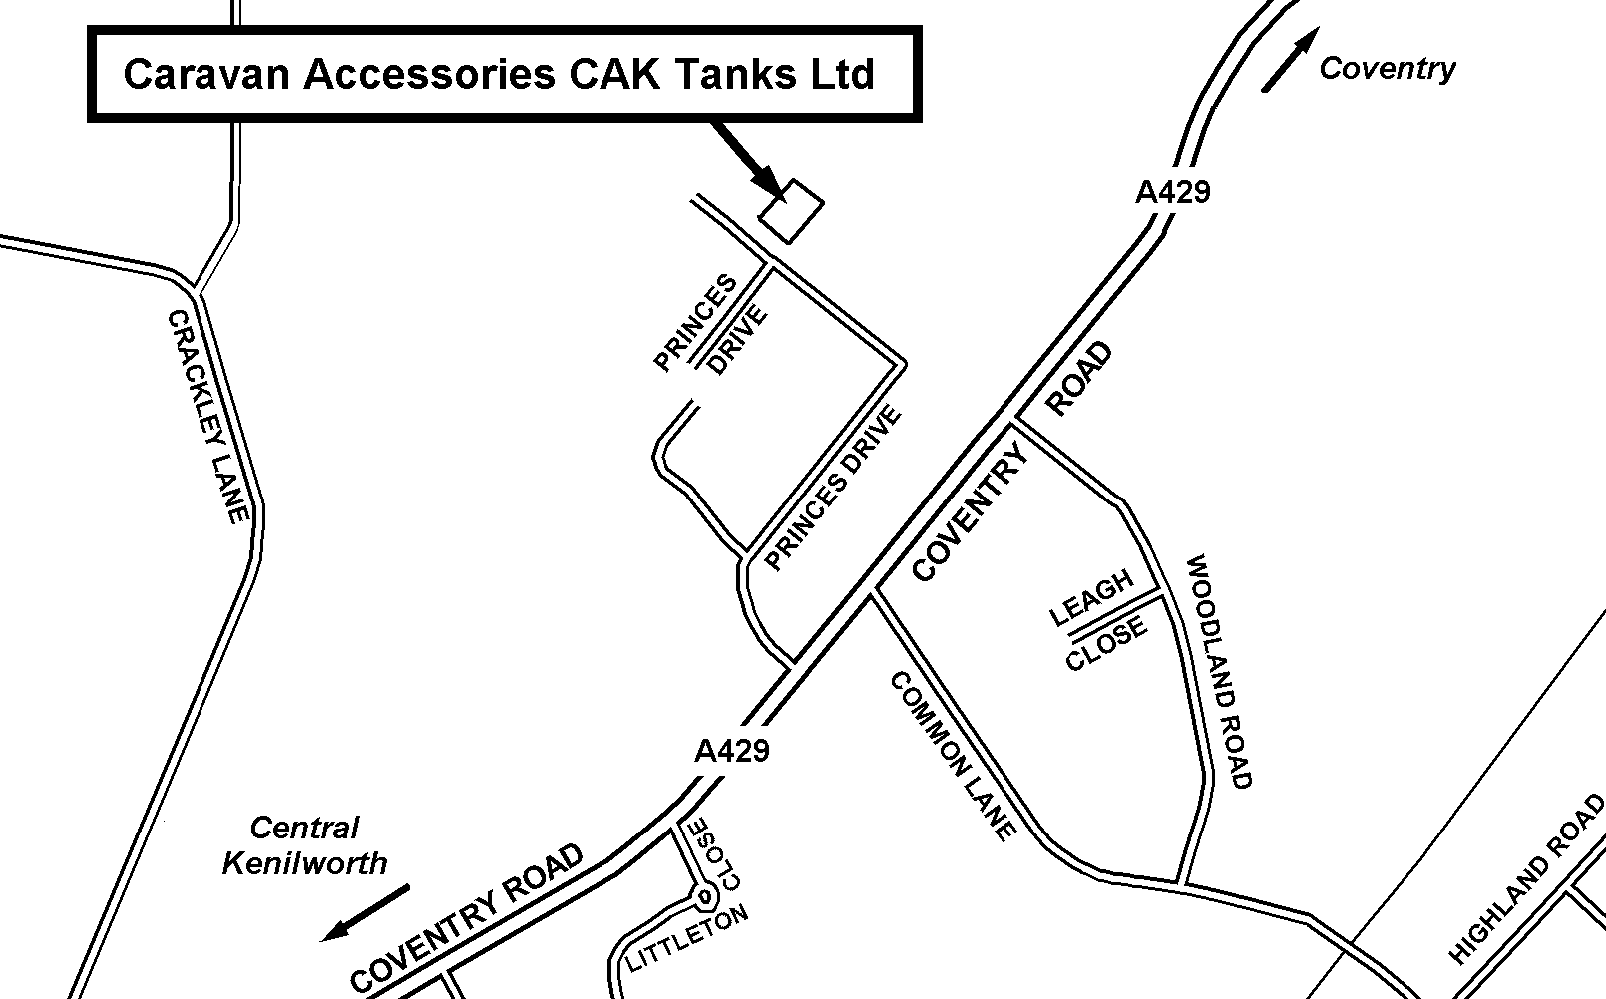
Reproduced from the Infomap, PJsoft Ordnance Survey map by permission of Ordnance Survey on behalf of the controller of Her Majesty’s Stationery Office, © Crown Copyright MC 100029112

